HIGHBURY TABLE TENNIS CLUB
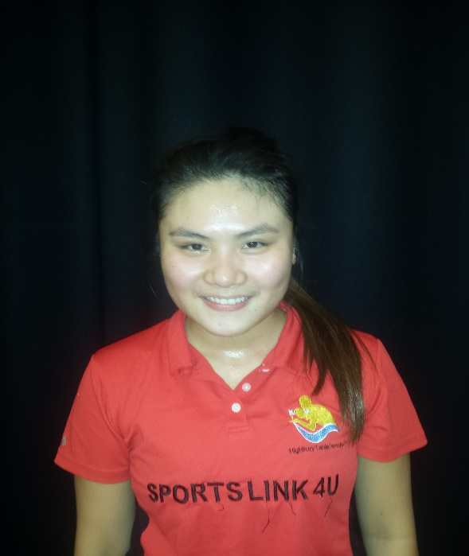
FEMALE TABLE TENNIS SESSION
STARTS FROM 3/10/2017 - 12/12/2017
TUESDAY 18.30pm – 20.30m
HIGHBURY GROVE SCHOOL N5 2EQ
Highbury Table Tennis club and Sports Islington organising Table Tennis session for female only, come and learn new sports, play for fitness, and have a lots of fun Equipment will be provided. Limited places first come first serve
Under 16 yrs old : £4 per session or £36 For 12 sessions
Highbury Club Members : £4 per session or £36 for 12 sessions
None Members : £8 per session or £60 for 12 sessions
NAME
EMAIL
CONTACT NO
ARE YOU HIGHBURY CLUB MEMBER?
PAYMENT BY BACS  £36 FOR 12 SESSIONS HTTC MEMBERS  £60 FOR 12 SESSIONS NONE MEMBERS | HIGHBURY TT CLUB  A/C 65464856  SORT CODE 089299
More information www.highburyttclub.co.uk
CONTACT SANKET : 07886685393 email : sanketshahba@yahoo.co.uk

