HIGHBURY TABLE TENNIS CLUB  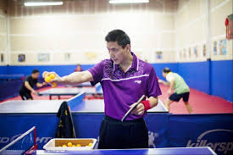  - table tennis coaching workshop  We are running Table Tennis Coaching Workshop for 6 weeks for under -16. You will learn basic to advance skills 9 hours of pure table tennis suits your needs.  Table Tennis Session will be organized by UKCC Level-2  DBS CHECK AND QUALIFIED FIRST AIDER  - Only 16 Places for this Course, First come First Serve  NAME  PARENT CONTACT  EMAIL  ADDRESS  Cost : £42  Pay by Bacs S SHAH A/C 71499669 SORT CODE 09 01 26 |  | 6 Weeks Course  Intensive Workshop  Date: 17.10.17 16.30-18.00  - Backhand Push  - Forehand Push  Date: 24.10.17 16.30-18.00  - Forehand Drive  - Backhand Drive  Date 31.10.17 16.30- 18.00  - Footwork  - Serving / Receiving  Date 7.11.17 16.30- 18.00  - Forehand Loop  - Backhand Loop  Date:14.11.17 16.30- 18.00  - Game plan/ Tactics  - 3rd Ball / 5th Ball  Date:21.11.17 16.30-18.00  - Tournament  - Awards Presentation  Mildmay Community Centre  Woodville Road  N16 8NA  TUESDAY 16.30-17.00  COACH: JOHN KESSIE 07956931042  sanketshahba@yahoo.co.uk
For more info: www.highburyttclub.co.uk Sanket 07886685393 email: sanketshahba@yahoo.co.uk

