MEMBERSHIP FORM  1ST JUNE 2021- TILL 31 MAY 2022  NAME:_____________________  CONTACT:_________________  EMAIL:____________________  DIVISION:_____TEAM _______  Full Membership Adult £120  Social / None League Player £90  Junior U-16/ Full Time Student £75  Member Drop in Session £5  Guest Fees Per Session £10  Family / Couple Membership £200  Highury TT Club A/c 65464856 Sortcode 089299  All Membership Expire 31/5/2022 | Table Tennis England registered premier Highbury Table Tennis Club is for all abilities, young and old, male and female and people with additional support needs. The club has various venues offering wide range of table tennis activities for Juniors, Female Players, Drop in sessions, Coaching much more… We have TTE qualified & experienced coaches, run fun training sessions and over 120 players registered and 16 teams enter taking part in Central Table Tennis League. The club is suitable for beginner, intermediate and advanced players. The club is open most Monday, Wednesday, Thursday, Friday evenings and Saturday throughout the year. , Whether you want to learn a new sport, keep fit, meet new people, practice with a friend, improve your existing ability or become a table tennis champion, this is the club for you! . .  Venues:  St Aloysius’ College Hornsey Lane, Highgate N6 5LY (Mon)  Bridge Academy Hackney E2 8BA ( Wednesday, Thursday & Sat)  Mildmay Centre N16 8NA (Tue)  Head Coach Sanket Shah Asst Coach -Peter  (UKCC-2/TTE-3) 07886685393  Email:sanketshahba@yahoo.co.uk | - 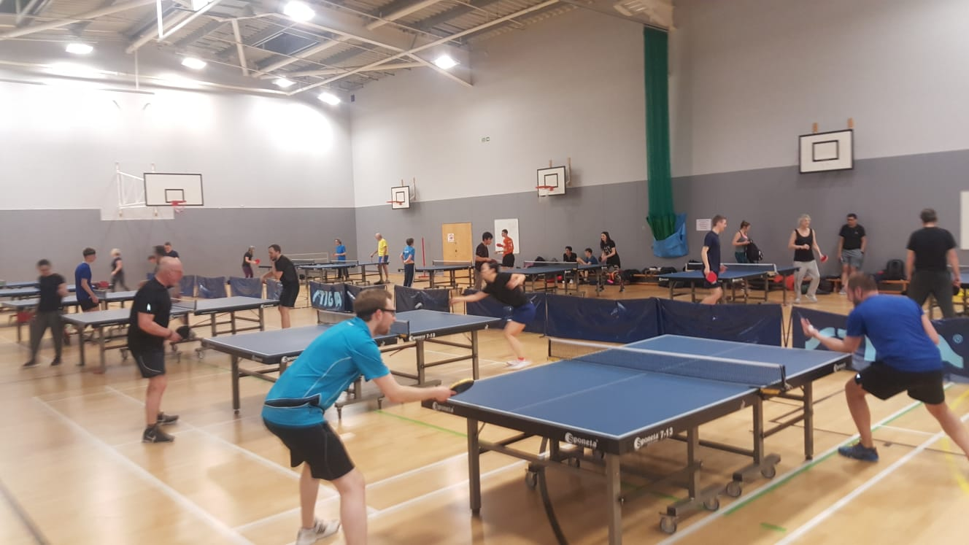  Drop in Sessions Day/ Time/ Venue  Monday :1800- 2000 Drop in @ N6 5LY (35 Max)  Tues :18.30- 20.30 @ N16 8NA ( 10 Max )  Wednesday: 1830-2030 Drop in @E2 8BA (35 Max)  Thursday: 1830- 2030 Drop in / League @ E2 8BA  Sunday : 1100-1300 Drop in @E2 8BA ( 35 Max)
op

